EXP - 1
AIM:
To create a personal portfolio web page that embeds a map with interactive hotspots, frames, and navigation links using HTML. The web page is styled using external, embedded, and inline CSS to enhance visual presentation. This experiment helps in understanding how to integrate multimedia elements such as maps, create clickable image hotspots, organize content using frames (iframe), and apply different CSS techniques for designing a professional portfolio website.

ALGORITHM:
1. Create the Basic HTML Structure:
- Begin with the standard HTML document structure using <!DOCTYPE html>, <html>, <head>, and <body> tags.
- Define the title of the webpage inside the <title> tag.
- Add meta tags if required for responsiveness.
- Link the external CSS file using the <link> tag inside the <head> section.
- Add embedded CSS using the <style> tag inside the <head> section for specific elements.
- Use inline CSS within certain tags in the <body> to demonstrate inline styling.

2. Design the Page Layout:
- Add a heading to welcome users to the portfolio creation website.
- Include descriptive text explaining the purpose of the website.
- Create a navigation link to the registration page using the <a> tag.
- Organize the content properly using headings and sections.

3. Add Image with Hotspots:
- Display an image representing a profile or GitHub section using the <img> tag.
- Use the <map> tag to define an image map.
- Inside the <map> tag, use <area> tags to define clickable hotspot regions.
- Specify coordinates using the coords attribute to make certain parts of the image clickable.
- Link the hotspot to an external website such as GitHub.
- Ensure the image is connected to the map using the usemap attribute.

4. Embed a Map Using Frame (iframe):
- Use the <iframe> tag to embed a Google Map showing a specific location.
- Set the src attribute with the Google Maps embed link.
- Define width and height attributes.
- Add additional attributes like allowfullscreen and loading for better performance.
- Position the map at the bottom of the webpage.
- Add a message indicating that users can add their own location.

5. Apply CSS Styling Techniques:
External CSS:
- Create a separate CSS file.
- Define global styles such as font family, background color, text alignment, button styles, hover effects, and smooth transitions.
- Apply RGB color combinations with black for a modern theme.
- Use Google Fonts such as Cabinet Grotesk and Fraunces to match the portfolio style.
Embedded CSS:
- Use the <style> tag inside the <head> section.
- Apply styles specifically for headings and selected elements.
Inline CSS:
- Use the style attribute directly within HTML elements.
- Apply background gradients and specific text styling directly inside tags.

6. Add Navigation Links:
- Use the <a> tag to create a link that redirects users to the registration page.
- Use the target="_blank" attribute for external links such as GitHub.
- Style the links using CSS to make them appear as buttons.

7. Test the Webpage:
- Open the webpage in a browser.
- Verify that:
  - The hotspot image is clickable and redirects correctly.
  - The embedded Google Map loads properly.
  - The navigation link redirects to the registration page.
  - Inline, embedded, and external CSS styles are properly applied.
  - Smooth transitions and hover effects work correctly.
Program:
Index.html:
<!DOCTYPE html>
<html>
<head>
<title>Create Your Portfolio</title>

<!-- External CSS -->
<link rel="stylesheet" href="style.css">

<!-- Google Fonts (Same as your portfolio) -->
<link href="https://fonts.googleapis.com/css2?family=Cabinet+Grotesk:wght@400;600;700&family=Fraunces:wght@500;700&display=swap" rel="stylesheet">

<!-- Internal CSS (Experiment 1 Requirement) -->
<style>
h1 {
font-family: 'Fraunces', serif;
font-size: 40px;
color: rgb(255, 94, 168);
}
</style>
</head>

<!-- Inline CSS (Experiment 1 Requirement) -->
<body style="background: linear-gradient(135deg, black, rgb(25,25,112), rgb(75,0,130)); color:white; text-align:center;">

<h1>Welcome! Create Your Own Personal Portfolio Website</h1>

<p class="sub-text">Build your professional website easily and beautifully.</p>

<!-- Link to Registration Page -->
<a href="register.html" class="main-btn">Register Now</a>

<!-- Image Hotspot -->
<h2 class="section-title">Add Your GitHub Profile</h2>

<img src="https://encrypted-tbn0.gstatic.com/images?q=tbn:ANd9GcRZfLuviePOqQJ1yuhvxr80AsqV91Btr2rqZw&s"
usemap="#githubmap"
class="github-image">

<map name="githubmap">
<area shape="rect"
coords="0,0,500,500"
href="https://github.com/"
target="_blank"
alt="GitHub">
</map>

<p class="info-text">You can add your GitHub too.</p>

<!-- Embedded Google Map -->
<h2 class="section-title">Your Location</h2>

<iframe src="https://www.google.com/maps/embed?pb=!1m18!1m12!1m3!1d60062.45093844654!2d77.4150323!3d8.1713051!2m3!1f0!2f0!3f0!3m2!1i1024!2i768!4f13.1!3m3!1m2!1s0x3b04f0dfc0ddc7b7%3A0x809a9e32a95d3ed1!2sNagercoil%2C%20Tamil%20Nadu!5e1!3m2!1sen!2sin!4v1771861432776!5m2!1sen!2sin"
width="600"
height="450"
style="border:0;"
allowfullscreen=""
loading="lazy"
referrerpolicy="no-referrer-when-downgrade"
class="map-box">
</iframe>

<p class="info-text">You can add your location too.</p>

</body>
</html>
style.css:
body {
margin: 0;
font-family: "Cabinet Grotesk", sans-serif;
text-align: center;
background: linear-gradient(135deg, black, rgb(25,25,112), rgb(75,0,130));
color: white;
}

/* Smooth transition */
* {
transition: all 0.4s ease-in-out;
}

/* Headings */
h1, .section-title, .form-heading {
font-family: "Fraunces", serif;
}

.sub-text {
font-size: 18px;
color: rgb(200,200,255);
}

.section-title {
margin-top: 40px;
color: rgb(98,242,116);
}

.info-text {
color: rgb(255,200,87);
margin-bottom: 40px;
}

/* Button */
.main-btn {
display: inline-block;
padding: 12px 25px;
background: linear-gradient(120deg, rgb(255,94,168), rgb(138,122,255));
color: white;
border-radius: 25px;
text-decoration: none;
font-weight: 600;
margin: 20px;
}

.main-btn:hover {
transform: scale(1.08);
}

/* GitHub Image */
.github-image {
width: 250px;
border-radius: 20px;
box-shadow: 0 10px 30px rgba(255,94,168,0.5);
}

.github-image:hover {
transform: scale(1.1);
}

/* Map */
.map-box {
border-radius: 20px;
border: 3px solid rgb(255,200,87);
margin-top: 20px;
}

/* Form */
.form-box {
width: 350px;
margin: 40px auto;
padding: 20px;
background: rgba(255,255,255,0.95);
border-radius: 15px;
color: black;
}

input, textarea {
width: 100%;
padding: 8px;
margin: 8px 0;
border-radius: 8px;
border: 1px solid gray;
}
OUTPUT:
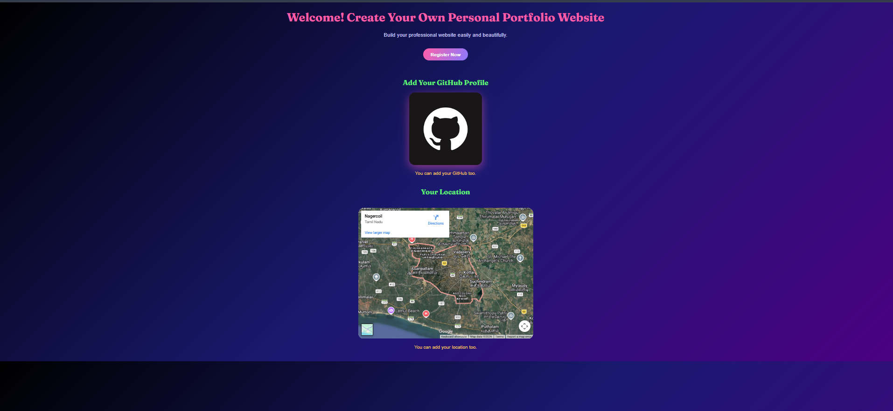
RESULT:
The web page was successfully created with an embedded Google Map, interactive image hotspot, and navigation links. Inline, embedded, and external CSS were applied properly for styling. All elements worked correctly when tested in the browser.

